000000000PE
Fatigue strength of gray iron and compacted graphite iron used for engine cylinder blocks
Wilson Luiz Guesser
Isaías Masiero
UDESC and Tupy Fundições
Eitan Melleras
Carlos Cabezas
Tupy Fundições
Copyright © 2004 Society of Automotive Engineers, Inc

ABSTRACT

The fatigue strength of gray iron and compacted graphite iron (CGI) was studied, looking for increase service life of engine blocks at high specific power. Push-pull fatigue test were conducted, with samples from the main bearings of a V6 2.7 L (60 kg) and an I6 5.9 L (150 kg) diesel engine cylinder blocks. Gray iron grade 250 with 3 different carbon contents and with Ultimate Tensile Strength ranging from 215 to 245 MPa (samples from the casting) were tested, comparing with a compacted graphite iron grade 450. Those grades (gray and CGI) are normally used for the production of cylinder blocks and they present almost 100% pearlite in the matrix and hardness numbers lower than 255 HB. The results show that the fatigue limit of gray iron grade 250, CuSnCr alloyed, can change from 62 to 79 MPa, depending on the carbon content of the gray iron. Increase in the carbon content result in larger graphite flakes, reducing in this way the fatigue strength of the gray iron. For the CGI grade 450, the fatigue limit was 175 MPa, as a result of the modification of the graphite shape, from discs for gray iron to rods for CGI.
The fatigue fracture mechanism of CGI was studied, showing that the fracture is associated with a large number of small cracks under the fracture surface. Those cracks are connected with the graphite particles, revealing the effect of the graphite acting as a local stress riser.

INTRODUCTION

In the development of new engines, there is a trend to increase the specific power of the engine and to reduce its weight. The reduction of the weight of the engine started with the cylinder head, with the use of aluminium cylinder heads, and is now concentrated on the cylinder block.
At the same time, for diesel engines, the peak firing pressure has been increased up to 180 bar, in order to reduce emissions. Figure 1 shows these tendencies.

Figure 1 – Time evolution of diesel engines specific power, according to FEV (Bick, 2003)

Those trends resulted in increased stresses for the cylinder block, putting new opportunities for the materials used for engine cylinder blocks. In figure 2 it is compared Gray Iron, CGI and AlSi9Cu related to important properties for cylinder blocks and cylinder heads (Bick, 2003). It can be seen the low density and high thermal conductivity of aluminum alloys, the main reasons for the use of aluminum in cylinder heads.

Figure 2 – Materials used for cylinder blocks – CGI 400, Gray Iron 250 and AlSi9Cu (FEV – Bick, 2003)

However, aluminum alloys will hardly endure the high peak firing pressure numbers mentioned before for cylinder blocks (Martin et all, 2003). Some studies from AVL set limits of 150 bar (for in-line engines) and 130 bar (for V engines) for aluminum in diesel engine cylinder blocks (figure 3, Marquard & Sorger, 1997).

Figure 3 - Peak firing pressure limits for various materials in diesel engine cylinder block (AVL - Marquard & Sorger, 1997)

The advent of compacted graphite iron allowed higher mechanical strength (fig.2), with new opportunities for the designers, but also bringing higher production costs. Therefore, some companies still avoid producing cylinder blocks in compacted graphite iron, trying to enhance the mechanical properties of gray iron through acting on the matrix and on the size and amount of graphite flakes.
The aim of this work is study the fatigue strength of compacted graphite iron, comparing it to the fatigue strength of gray irons with different carbon levels.

EXPERIMENTAL PROCEDURES

Two series of experiments were done. In the first series, it was done push-pull and rotating bending fatigue test, with the samples obtained from the main bearings of a 2,7 L V6 cylinder block (60 kg), in order to study the CGI fatigue strength. In the second series, the fatigue strength of CGI Grade 450 (CGI #3) was compared to Gray Iron Grade 250, CuSnCr alloyed, with the samples obtained from the main bearings of a 5,9L I6 cylinder block (150 kg).
Table I shows the microstructure and the mechanical properties of the tested materials.

Table I – Microstructure and mechanical properties of the cast irons. Samples from the main bearings of the cylinder block.
Material | Cylinder block | UTS MPa | YS MPa | Nodula-rity % | Ferrite %
CGI #1 | V6 – 60 kg | 455 | 342 | 15-20 | 10-15
CGI #2 | V6 – 60 kg | 466 | 342 | 9 | 6
CGI #3 | I6 – 150 kg | 452 | 365 | 2-4 | 1-2
 |  |  |  | Graphite size^{(*)}
Gray Iron #1 | I6 – 150 kg | 209-215 | - | 3 – 4 | 0
Gray iron #2 | I6 – 150 kg | 229-244 | - | 4 – 5 | 0
Gray iron #3 | I6 – 150 kg | 238-254 | - | 4 – 5 | 0
(*) – According to DIN EN ISO 945.

The push-pull fatigue tests were conducted on a MTS-810 machine, with R =-1 and 10 Hz. The diameter of the samples was 10 mm.
For the rotating bending tests, the samples show a diameter of 8 mm and 50 mm radius. The test were conducted on a WEB-UBM machine, with R=-1 and 50 Hz.
The tests were conducted up to 10 million cycles.

RESULTS AND DISCUSSION

In figure 4 it is presented the results of the rotating bending tests, for the CGI Grade 450 (CGI #1). The fatigue limit for this material is 200 MPa, with an endurance ratio of 0,44. Similar results were obtained by Palmer (1976).

Figure 4 – Results of rotating bending fatigue tests. Fatigue limit = 200 MPa, endurance ratio = 0,44. CGI #1, main bearings of V6 cylinder block.
Push-pull test results can be observed on figure 5, with CGI #2. The results show that the fatigue limit is 185 MPa, with an endurance ratio of 0,39. These numbers are higher than those reported by Bhandhubanyong et all (1982), with a fatigue limit of 160 MPa and endurance ratio of 0,32.

Figure 5 – Results of push-pull tests. Fatigue limit = 185 MPa, endurance ratio = 0,39. CGI #2. Main bearings of V6 cylinder block.

In the second experimental series, the goal was to compare the fatigue results of CGI Grade 450 with those obtained with gray irons. All the gray irons tested presented a fully pearlitic matrix, so the way to increase the fatigue strength was to decrease the carbon content, reducing in this way the size and the amount of the graphite particles. The results for the gray irons are presented on figures 6-8, with a summary of the results on figure 9. One can see that reducing the carbon content increases the fatigue limit, and the best fatigue strength (79 MPa, fig 9) was obtained with the gray iron with the lowest carbon content (3,95-3,98% CE).

Figure 6 – Fatigue results of Gray Iron #1. Push-pull. Fatigue limit of 63 MPa. Main bearings of I6 cylinder block.

Figure 7 – Fatigue results of Gray Iron #2. Push-pull

Figure 8 - Fatigue results of Gray Iron #3. Push-pull

Figure 9 – Fatigue limit and ultimate tensile strength of gray iron, related to the carbon equivalent content. Samples from the main bearing of a 5,9 L I6 cylinder block. Push-pull.
The result for CGI 450 (also samples from the I6 cylinder block) is presented on figure 10, with a fatigue limit of 175 MPa, much higher than the values reached with the gray iron. So, it’s possible to note a considerable increasing in the fatigue strength , when moving from gray iron to CGI.

Figure 10 - Fatigue results of CGI #3. Main bearings of I6 cylinder block. Fatigue limit = 175 MPa, endurance ratio = 0,39.

Those results are summarized on table II.

Table II – Fatigue limit results of CGI and Gray Iron with different carbon levels.
V6 cylinder block
Material | Fatigue Limit
CGI #1 | rotating bending  200 MPa
CGI #2 | Push-pull  185 MPa
I6 cylinder block
Material | Fatigue Limit (push-pull)
Gray iron #1 | 63 MPa
Gray iron #2 | 72 MPa
Gray iron #3 | 79 MPa
CGI #3 | 175 MPa

It can also be seen that CGI #2 and CGI #3, with the samples obtained from different castings, although showing different fatigue limits, presented the same endurance ratio (0,39 for push-pull conditions, figures 5 and 10). It can be noted that the increase in the strength, as a result of the higher nodularity, led to a proportional increase in the UTS and fatigue limit. Beyond that, knowing the tensile strength of a CGI, it’s possible to estimate with high precision the fatigue limit, through the endurance ratio.
The fracture surface of CGI samples were also evaluated, as well the orthogonal sections related with the fracture, in order to verify the fracture mechanism. Figure 11 shows, in the tensile test, that there are few cracks under the fracture surface (main crack) and those cracks are connected with the main crack. Figure 12 shows that, in fatigue service, there is a formation of a high number of small cracks under the fracture surface (main crack). Many of the small cracks are connected with the graphite particles, showing that the graphite particles are working as crack initiating sites.

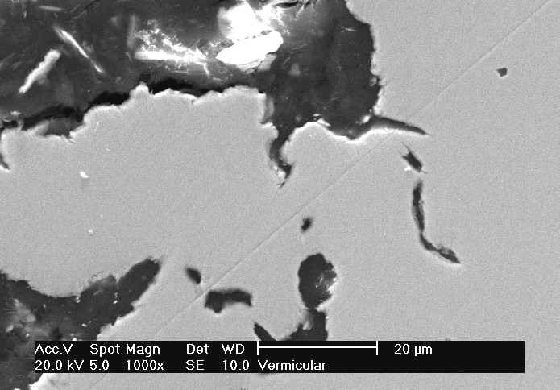

Figure 11 – Longitudinal section of the tensile test sample. Cracks connected to the fracture surface. CGI #2.

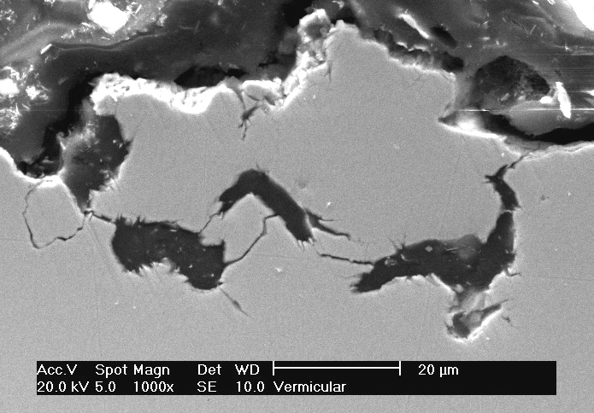

Figure 12 – Longitudinal section of the fatigue test sample. Large number of cracks under the fracture surface. CGI #2.

Figures 13 to 17 show fractographies from the tensile test fracture (fig 13 and 14) and fatigue fracture (fig 15 to 17). In the tensile test fracture, it was verified the occurrence of clivage mechanism (fig 13) and micro-dimples (fig 14). In the samples fractured by fatigue, one can see the fatigue striation in the pearlite (figures 15 to 17), corresponding to the fluctuating stresses. These fatigue striations are different from the ductile fracture of pearlite in tensile test (fig 14). The fracture of pearlite under tensile test conditions reveals the lamelar arrangement of the pearlite, with changing orientation from one colony to another. The striations in the fatigue fracture is oriented according the stress direction, and is independent from the pearlite lameles positioning.

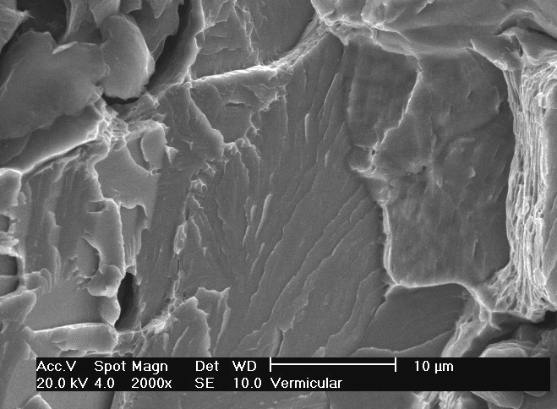

Figure 13 – Tensile test fracture of CGI #2. Clivage.

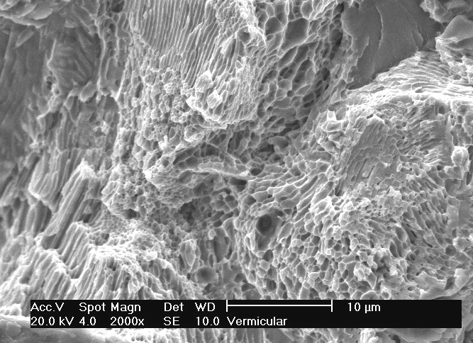

Figure 14 - Tensile test fracture of CGI #2. Micro-dimples in pearlite.

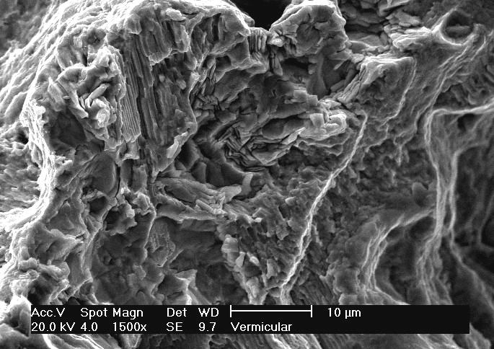

Figure 15 – Fatigue fracture of CGI #2.

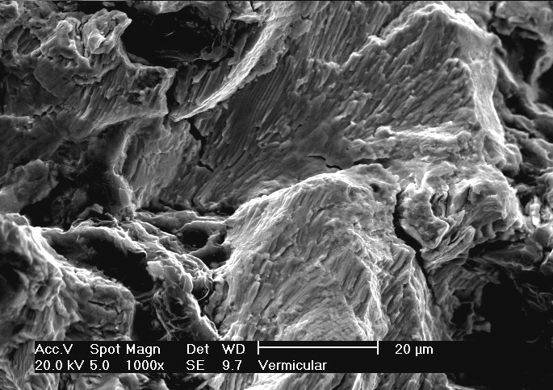

Figure 16 – Fatigue fracture of CGI #2. Fatigue striation on the pearlite.

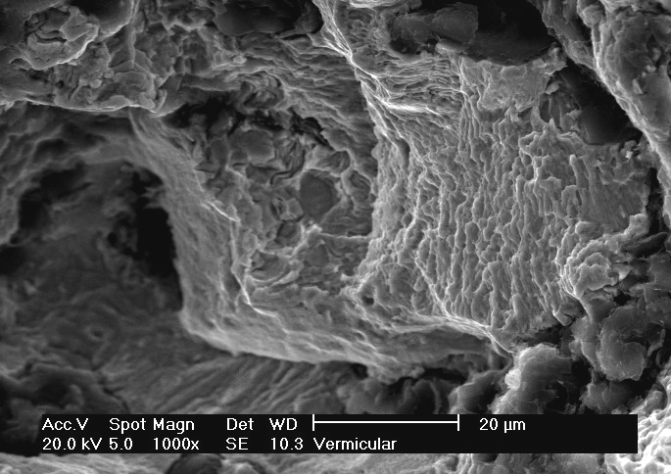

Figure 17 – Fatigue fracture of CGI #2. Fatigue striation.

CONCLUSIONS

Based on the results we can conclude:
- Samples from V6 cylinder block, casted with CGI Grade 450, presented a rotating bending fatigue limit of 200 MPa, with an endurance ratio of 0,44. The push-pull fatigue limit for those samples was 185 MPa, with an endurance ratio of 0,39.
- Samples from a I6 cylinder block (150 kg) showed a push-pull fatigue limit of 175 MPa, with an endurance ratio of 0,39. Gray iron samples from the I6 cylinder block showed increasing fatigue limit with decreasing carbon content, with the highest fatigue limit of 79 MPa for the gray iron with 3,95-3,98% CE.
- The fracture of the CGI fatigue samples show a large number of small cracks under the main crack. The fracture surface show striations, typical of fatigue fractures.

REFERENCES

Bhandhubanyong, P, Umeda, T, Kimura, Y. “Fatigue
strength and crack propagation in spheroidal,
compacted vermicular and flake graphite cast irons.”
IMONO, vol 54, n. 12, 1982.
Bick, W et all. “Light weight engine concepts for 200 bar
peak firing pressure”. 5th CGI Machining Workshop.
Darmstadt, Germany, Sept 2003.
Marquard, R & Sorger, H. “Modern Engine Design”. CGI
Design and Machining Workshop, Sintercast – PTW
Darmstadt, Bad Homburg, Germany, Nov 1997.
Martin, T; Weber, R; Kaiser, R.W. „Dünnwandige
Zylinderblöcke aus Gusseisen“. Giesserei-
Erfahrungsaustauch, n.8, 2003, pp. 357-362.
Palmer, K. B. “Mechanical properties of compacted
graphite iron”. BCIRA Report 1213, pp 31-37, 1976

